Phase 4
Post Exploitation

Post Exploitation Activities
After Obtaining the interactive shell on the target machine Metasploitable 2 System, we tried to escalate the privileges and perform Digital Forensics Exercise by collecting the file and hashing it for further file integrity Purposes.

Privilege Escalation
Upon exploitation , a remote shell session was established and the privilege level was checked.

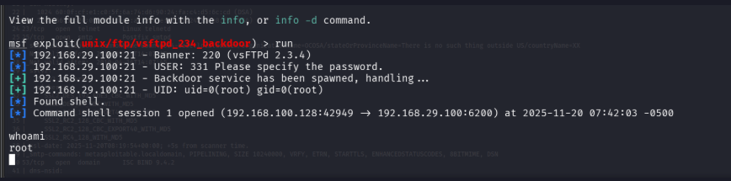

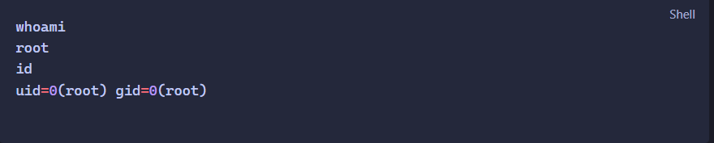

Result:
Full Root Privileges were confirmed on the Target.

Evidence Collection
A file on the system /etc/passwd was download from the target machine to the attacker machine. This file contains the account information and is commonly used in post exploitation.

The file was hashed using SHA-256 to ensure the file integrity for future Digital forensics purposes.
